**Project Plan**

For a Track & Field Meet Server

Version 1.0

Submitted in partial fulfillment of the requirements of the degree of MSE

Tracy Marshall

CIS 895 – MSE Project

Kansas State University

# Table of Contents

Table of Contents 2

1. Introduction 3

2. Work Breakdown Structure 3

2.1. Inception Phase 3

2.2. Elaboration Phase 4

2.3. Production Phase 4

3. Cost Estimate 5

3.1. COCOMO 5

4. Architecture Elaboration Plan 6

4.1. Revise Vision Document 6

4.2. Revise Project Plan 7

4.3. Create Formal Specification 7

4.4. Create Architectural Design 7

4.5. Create Test Plan 7

4.6. Conduct Technical Inspection 7

4.7. Create Executable Architecture Prototype 7

# Introduction

This document will act as the initial project plan for the Track & Field Meet Server project. This document will seek to outline the work breakdown structure for the project. It will use the COCOMO model to provide cost estimates and will take a look at the tasks that will be performed during the elaboration phase of the project.

# Work Breakdown Structure

This project will be executed using an iterative process. The project will have three phases which will include the Inception phase, Elaboration phase, and Production phase. During each phase all components of the design process will be gone through, including requirements gathering, design, and implementation. Each phase will work to build on the previous phase and mature the project more and more. The first phase will be completed by the end of the Summer 2016 semester. The second and third phases will be completed during the Fall 2016 semester. Below is a Gantt chart that lays out the schedule for the project and the proceeding sub sections will give a more detailed description of each of the phases.

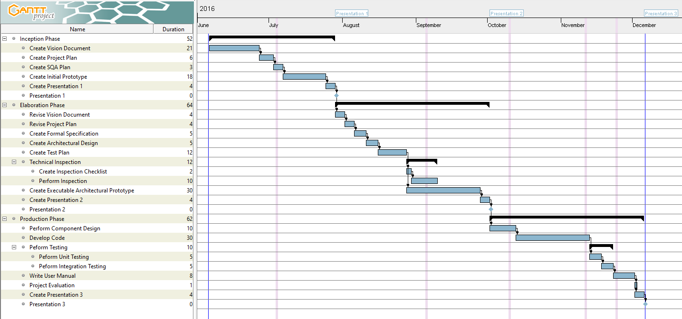

Figure 2.0-1 – Project Gantt Chart

## Inception Phase

The inception phase will have three documents delivered by the end of it. These documents include the vision document, project plan, and Software Quality Assurance (SQA) plan. Along with these documents an initial prototype will be developed and a presentation will be given. The vision document will overview the project and provide the critical requirements for the project. The project plan will give details about all of the work that must be done to get through each of the phases of development. The SQA plan will explain the documentation that must be delivered during the project and processes that will be followed during development. An initial prototype will be developed to demonstrate a high level functioning of the project and to prove feasibility. Finally, all of the documents and prototype will be presented to the supervisory committee.

The inception phase will be considered finished upon approval of all deliverables by the supervisory committee.

## Elaboration Phase

The elaboration phase will revise the vision document and project plan based on feedback given from the committee members during the inception phase presentation. The project architecture will be designed and captured with UML diagrams. At least one of the components of the project will be specified using a form of formal specification. While the architecture is being developed there will be reviews conducted by two technical inspectors. The technical inspectors will provide feedback that will drive refinement of the architecture. A software test plan will be created to define the testing process that will be followed during the project. The prototype from the first phase will continue to be developed to demonstrate more of the architecture. Finally, all of the documents and the prototype will be presented to the supervisory committee.

The elaboration phase will be considered finished upon approval of all deliverables by the supervisory committee.

## Production Phase

The production phase will complete the low-level component design and finalize all deliverables. Testing will be conducted as defined in the test plan developed in the elaboration phase. Unit test will be conducted for each component and then integration testing will be conducted on the entire system. A user manual will be developed after the completion of testing. Finally, the project evaluation will be conducted and a presentation will be given to the supervisory committee to present all of the documents and the prototype.

The production phase will be considered finished upon approval of all final project deliverables by the supervisory committee.

# Cost Estimate

## COCOMO

The cost estimation model that will be used for this project is the COCOMO model. This model was created in the eighties by Barry Boehm. The purpose for this model was to find a way to effectively estimate the effort and time for a given project. The TFMS will be a self-contained system that will be developed for execution on a single computer. The system will be developed by an individual with software experience, but that is new to this development environment. The system will be average complexity and has a lot of flexibility on features and design details. The COCOMO model considers this particular project to be classified as organic which means that the following equations apply to the TFMS development:

$$Effort\left(staff-months\right)=3.2*EAF*{Size}^{1.05}$$

$$Time\left(months\right)=2.5*{Effort}^{0.38}$$

In the equations above, the size parameter is a lines of code estimate that is in units of KSLOC. Based on similar projects and experience with development efforts a good estimate to use for these equations is 2 KSLOC.

To determine the effort adjustment factor (EAF) a variety of attributes about the project are rated on a predetermined scale and the product of all the factors is found to be the EAF. The adjustment attributes that will be used are shown in the table below.



Figure 3.1-1 COCOMO Cost Drivers and Effort Multipliers

The following table shows the ratings that have been given to this project based on experience with similar projects.



Figure 3.1-2 COCOMO Attribute Ratings

This project relatively average complexity and does not require any sort of extreme level of reliability. The hardware components are not very strict for the TFMS system. I am very experienced with software development, but this project is outside of my normal development domain and will require me to develop in an environment I’m not use to and using a language that I have done minimal development with.

Based on the attribute ratings the EAF value comes to 1.10. Plugging this number into the effort equation the effort comes out to be:

$$Effort=3.2*1.10*2^{1.05}=7.29 staff-months$$

Using this calculated value in the time equation the time comes out to be:

$$Time=2.5*{7.29}^{0.38}=5.32 months$$

Based on my project schedule this time values seems to be plausible given the time constraints that I’m working within.

# Architecture Elaboration Plan

The following will overview the tasks that will be completed during the elaboration phase of the project.

## Revise Vision Document

Revisions will be made to the initial vision document to better define the project. The changes to the original document will be based on findings from the initial prototype and feedback given from the committee during the first presentation. The new revision of the vision document will be resubmitted to the major professor for approval.

## Revise Project Plan

Revisions will be made to the initial project plan to better define the plan for the remainder of the project. The changes to the original document will be based on deviations from the schedule during the inception phase and feedback from the committee given during the first presentation. The new revision of the project plan will be resubmitted to the major professor for approval.

## Create Formal Specification

The TFMS will be modeled and have a partial formal specification. The specifications will be submitted to the major professor for approval.

## Create Architectural Design

The TFMS will have its capture its architectural design using UML diagrams. These diagrams will capture various levels of functionality and will be reviewed by the project technical inspectors. The design will then be submitted to the major professor for approval.

## Create Test Plan

A test plan will be developed to define how the project will verify that the system requirements defined in the vision document have been met. The plan will define the criteria for unit and integration testing based on all of the critical use cases. Test data will be included in this document to demonstration a real use scenario. The test plan will be submitted to the major professor for approval.

## Conduct Technical Inspection

The technical inspectors for this project will be Keith Moyer and Blake Knedler. They will be inspecting the architectural design based on a checklist that will be developed and provided to them. Feedback from the technical inspectors will be responded to and revisions will be made when necessary. The checklist with reviewer feedback will be submitted to the major professor for approval.

## Create Executable Architecture Prototype

An executable architecture prototype will be developed and demonstrated to prove feasibility of the design to satisfy the crucial use cases that were defined in the vision document. The prototype will be demonstrated to the supervisory committee for comments and approval.